MARTHA BRONITSKY, CHAPTER 13 STANDING TRUSTEE
NORTHERN DISTRICT OF CALIFORNIA-OAKLAND DIVISION

Zoom Instructions for Meeting of Creditors
- If you are a Debtor's Attorney, share this information with your client in advance of the Meeting of Creditors.
- On the day of the scheduled Meeting of Creditors, access the Meeting by entering the Meeting ID and Password found in Section 7 of the Notice of Chapter 13 Bankruptcy Case (Office Form 309I, aka BNC Meeting of Creditors Certificate of Mailing). You can access the Meeting of Creditors (§ 341 Meeting) with any computer, laptop, tablet, or smartphone with a camera.
- When logging in, YOU MUST ENTER YOUR REAL NAME so the Trustee is able to identify you when your case is called. Failure to do so will result in denial of permission to enter the meeting room. If you are a creditor, please enter the name of the party your represent followed by “CR”.
- Join the room 10 minutes prior to your SCHEDULED MEETING TIME and test your audio and video feeds. Refer to Section 7 of the BNC Certificate of Mailing - Meeting of Creditors for the SCHEDULED MEETING TIME.
- Upon joining the meeting you will be placed in a waiting room; you will be brought in the room when your case is called. If prompted to join a Breakout Room, please accept the invitation. Please remain patient in the waiting room as technical difficulties may result in longer than expected wait times.
- Debtors should have their PHOTO ID and Social Security cards ready for verification.
- If a debtor needs the assistance of a language interpreter, Trustee’s office MUST receive notice at least 72 hours prior to the scheduled day of the meeting.
- If you are not familiar with Zoom’s videoconferencing service, please read through the detailed instructions attached. Counsel for must to conduct a practice run with clients. Please familiarize yourself thoroughly so as to avert a continuance. (Also see video tutorial: https://support.zoom.us/hc/en-us/articles/201362193-How-Do-I-Join-A-Meeting-).
- If you are not a debtor and would like information about dialing in with a telephone line, please submit a request to 13trustee@oak13.com 72 hours in advance. TELEPHONE ONLY IS NOT AN OPTION FOR DEBTORS.

How to Access the Meeting Based Upon Your Device:

DESKTOP COMPUTER/CPU:
- Equipment Needed: Camera, Speaker/Microphone or Camera and Telephone.
- Instructions: If you use the link in the email, you may not have to input all the information indicated below. Just follow the prompts as indicated.

- Click on the Link provided in the Meeting Email;

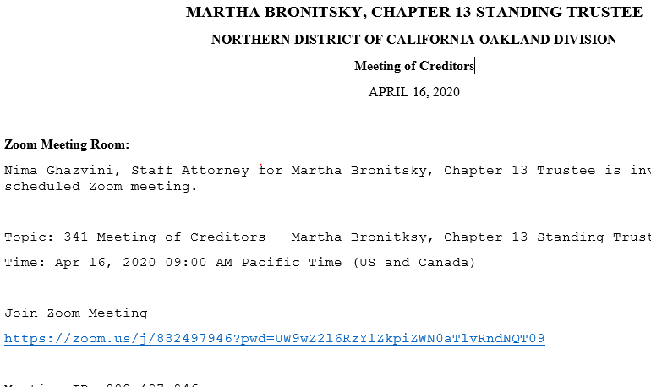

**If you access the Meeting from the link, you will likely will NOT need to enter the Meeting ID or Password. If you do not have an email link, you will have to enter the Meeting ID and Password. Please just follow the prompts.

- Select <DOWNLOAD AND RUN> to enable Zoom;

- Enter your FIRST and LAST NAME and the PASSWORD. Joint Debtors may enter full name of either debtor.

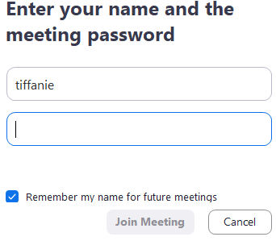
First Name and Last Name as it appears on your bankruptcy petition
Password

- Select <JOIN WITH COMPUTER AUDIO> (if you do not select this, I will not be able to hear you; you will need to dial-in by telephone – see below);

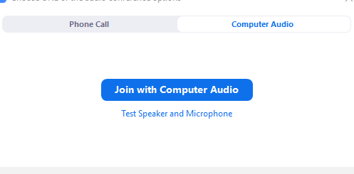

- “Waiting Room” – At this point you will be placed into a virtual “waiting room”. You will see a message that states some derivative of the following.

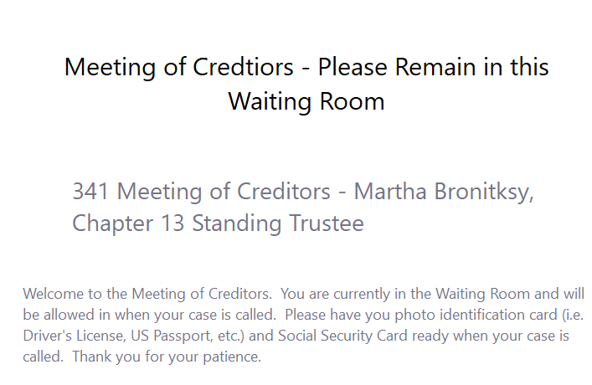

- Wait until the Trustee brings you into your Meeting.
***Please keep in mind, your case may not be heard at the exact Meeting time, but you are instructed to wait until your case is called. Wait times will vary depending on the number of cases set on the calendar and may exceed one hour.

LAPTOP:
- Equipment Needed: Laptop with a camera or a separate camera.
- Instructions:
- Click on the Link provided in the Meeting Email;
- Select <DOWNLOAD AND RUN> to enable Zoom;
- Enter your FIRST and LAST NAME (if you fail to enter this, it will show up as your email);
- Select <JOIN WITH COMPUTER AUDIO> (if you do not select this, I will not be able to hear you; you will need to dial-in by telephone – see below);
- “Waiting Room” – At this point you will be placed into a virtual “waiting room”. You will see a message that states some derivative of, “Please wait, the host is in another meeting and will let you in soon.”
- Wait until the Trustee brings you into your Meeting.
*** Please keep in mind, your case may not be heard at the exact Meeting time, but you are instructed to wait until your case is called. Wait times will vary depending on the number of cases set on the calendar and may exceed one hour.

IPAD:
- Equipment Needed: IPAD, as it should come with a built-in camera and speaker/microphone and download App - Zoom.
- Instructions:
- Click on link in meeting email or go directly to Zoom App and Select <JOIN A MEETING>. If you have not downloaded the App, you will likely have to do this first;
- Enter <MEETING ID> from the Meeting Email – STAY ON THIS SCREEN FOR STEP 3;
- Enter your FIRST and LAST NAME (if you fail to enter this, it will show up as your device name, e.g. “iPad” and thus, is unidentifiable);
- Enter the <MEETING PASSWORD>;
- Select <JOIN WITH VIDEO>;
- “Waiting Room” – At this point you will be placed into a virtual “waiting room”. You will see a message that states some derivative of, “Please wait, the host is in another meeting and will let you in soon.”
- Wait until the Trustee brings you into your Meeting.
*** Please keep in mind, your case may not be heard at the exact Meeting time, but you are instructed to wait until your case is called. Wait times will vary depending on the number of cases set on the calendar and may exceed one hour.

SMARTPHONE:
- Equipment Needed: Smartphone and download App – Zoom.
- Instructions:
- Click on link in meeting email or go directly to Zoom App and Select <JOIN A MEETING>. If you have not downloaded the App, you will likely have to do this first;
- Enter <MEETING ID> from the Meeting Email – STAY ON THIS SCREEN FOR STEP 3;
- Enter your FIRST and LAST NAME (if you fail to enter this, it will show up as your device name, e.g. “iPad” and thus, is unidentifiable);
- Enter the <MEETING PASSWORD>;
- Select <JOIN WITH VIDEO>;
- “Waiting Room” – At this point you will be placed into a virtual “waiting room”. You will see a message that states some derivative of, “Please wait, the host is in another meeting and will let you in soon.”
- Wait until the Trustee brings you into your Meeting.
*** Please keep in mind, your case may not be heard at the exact Meeting time, but you are instructed to wait until your case is called. Wait times will vary depending on the number of cases set on the calendar and may exceed one hour.

TELEPHONE:
THIS OPTION IS NOT AVAILABLE FOR DEBTOR(S) UNLESS YOU HAVE VIDEO AND USE THE TELEPHONE AS YOUR AUDIO
- Equipment Needed: Telephone.
- Instructions:
- Follow the instructions for your applicable Device until you reach the Step regarding
<JOIN WITH COMPUTER AUDIO> if you are using the video and telephone as your audio. Otherwise, just call the number in the email link that is applicable to your area.

- Select <PHONE CALL>. You will be connected to the meeting, but will not be seen.

- DIAL IN. For most individuals the telephone number will be the San Jose telephone no. 669.900.6833. HOWEVER, if you have dialed a number that is NOT accurate, the voice will indicate you have reached an incorrect phone number. PLEASE TRY THE NEXT TELEPHONE NUMBER.

- ENTER MEETING NUMBER. Once you dial the correct telephone number, you will be prompted to enter the Meeting Number followed by #.

- ENTER MEETING PASSWORD. Once you dial the correct Meeting Number you will be prompted to enter the PASSSWORD followed by #.

- PLACED ON HOLD. Once you enter the Meeting, you will be told to wait on HOLD. Please wait for me to bring you into the Meeting.

